NJLA YA Services Member Updates
September 24, 2010

My blog, A Chair, A Fireplace & A Tea Cozy has moved. It's now part of the School Library Journal website!
The new URL: http://blog.schoollibraryjournal.com/teacozy
The new feed: http://blog.schoollibraryjournal.com/teacozy/feed/
Liz Burns, New Jersey State Library Talking Book and Braille Center

Comic Book Workshop Series at Summit Free Public Library
Summit Library received a Union County HEART (History, Education, Arts Reaching Thousands) Grant for a series of Comic Book Workshops for teens featuring Peter and Bobby Timony. The Timonys, who are originally from New Providence, NJ, are the writers and creators of the web comic "The Night Owls," and have recently released a Night Owls compilation on Zuda imprint of DC Comics (Review: Booklist, May #1 2010). Workshops will take place Wednesdays in October from 6-7 PM.
Ann Marie Aymer, Summit Free Public Library

The Hillsdale Public Library held a number of craft programs this summer, but the
first was PAINT THE CEILING! I removed ceiling tiles from the Teen Area, carted
them to the meeting room and teens had the opportunity to paint whatever they
wanted. Now that the tiles have been re-installed it really helps to personalize
the space.
Laura Leonard, Hillsdale Public Library
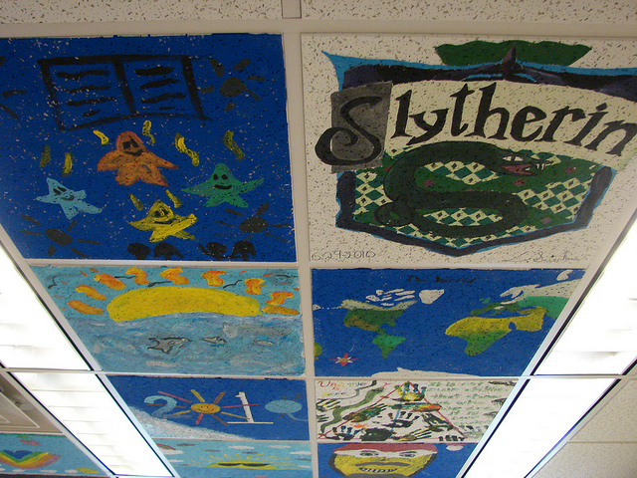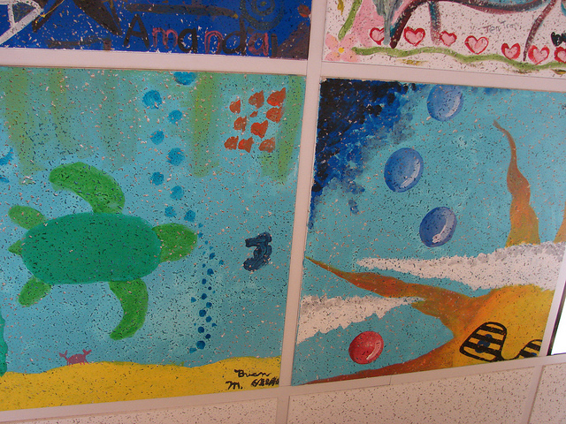

South Brunswick Public Library did a Kickoff Party/Dance competition in June. We had over 60 attend though sadly only 2 groups competed. We did have a "celebrity" judge; SmartMark from Phresh Select Crew who appeared on America's Best Dance Crew. He was very sweet and charming and a big hit with the kids as a judge and as a performer. If anyone wants his contact information, I am happy to provide it as he's from Philadelphia and could travel a reasonable distance. He also has a dance school in Phil (We Are Phresh school) so it's also possible to get multiple dancers if you wanted that. Saleena Davidson, South Brunswick Public Library
